**Project - Phase II: Decision Making**

Harsh Anand

Navya Akshitha Sangishetty

Nikitha Kakuru

Sampath Kumar Kuram

Department of Information Technology, Arizona State University

IFT 598 Data Visualization & Reporting for IT

Asmaa Elbadrawy

November 20, 2022

* **Used Visualization Tools**

We are using Tablue as our visualization tool, Since everyone is familiar with this tool so it will be easier for everyone to work on this tool .It also gives the flexibility to create different types chart and dashboard with very less effort. It is very good tool to add interactivity in different charts. It also supports to import the data from various sources like sql, remote server, csv, json file etc.

* **Explanation of Required Data Pre-processing, if any (2 point)**

No pre-processing required for our dataset.

* **List of Final Sets of Questions (20 points)**

1. Top N Countries/states with the highest number of deaths.

2. Top N countries/states with highest covid confirmed cases.

3. Top N Countries/states with the highest number of Recoveries

4. Daily trends of the total number of covid confirmed cases by countries.

5. Daily trends of the total number of covid recoveries by countries.

6. Daily trends of the total number of covid death by countries

7. Quarterly trends of the total number of covid confirmed cases by countries

8. Quarterly trends of the total number of covid recoveries by countries

9. Quarterly trends of the total number of covid death by countries

10. Monthly trends of the total number of covid confirmed cases by countries

11. Monthly trends of the total number of covid recoveries by countries

12. Monthly trends of the total number of covid death by countries

13. Trend showing daily cases, recoveries, and death by countries.

14. Trend showing Quarterly cases, recoveries, and death by countries

15. Trend showing monthly cases, recoveries, and death by countries

16. Total confirmed cases, recovery, and death in different nations across the world.

17. Total number of Confirmed, Recoveries and Deaths per year/month/day.

**Section 4: Dashboard Plots (10 points)**

**1.** Top N Countries/states with the highest number of deaths: Bar Graph, Top N filter  
 **Explanation**: This visualization depict Top N countries with highest number of deaths. The

user can enter the Top N value in the filter and based on the value the graph will change.  
 **Chart Type**: Vertical Bar Chart

**Pre-Attentive Attributes:** Color Hue, length

**Rough Sketch:** 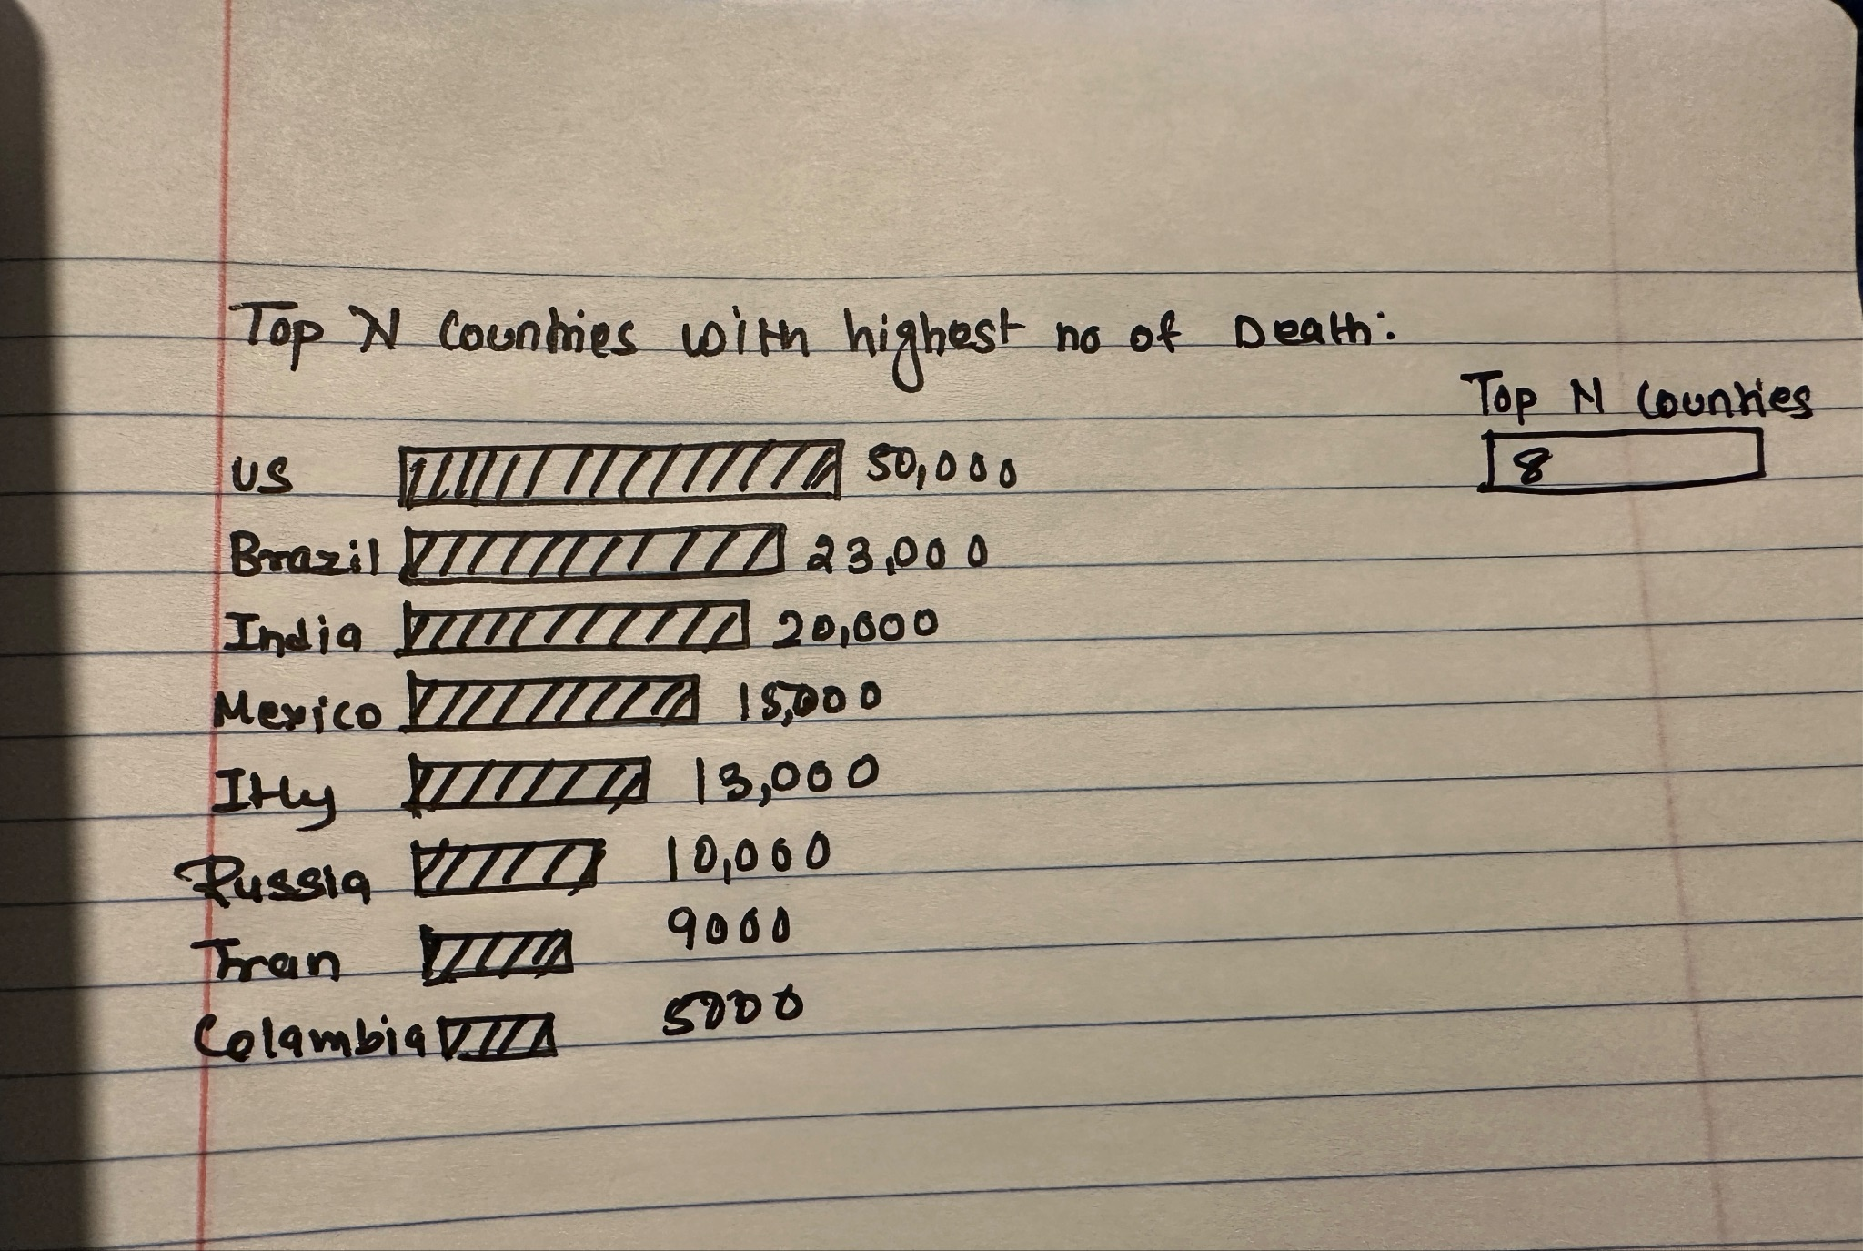

**2.** Top N countries/states with highest covid confirmed cases: Bar Graph, Top N filter  
 **Explanation**: This visualization depict Top N countries with highest number of confirmed. The

user can enter the Top N value in the filter and based on the value the graph will Change.

**Chart Type**: Vertical Bar Chart

**Pre-Attentive Attributes:** Color Hue, length  
 **Rough Sketch**:

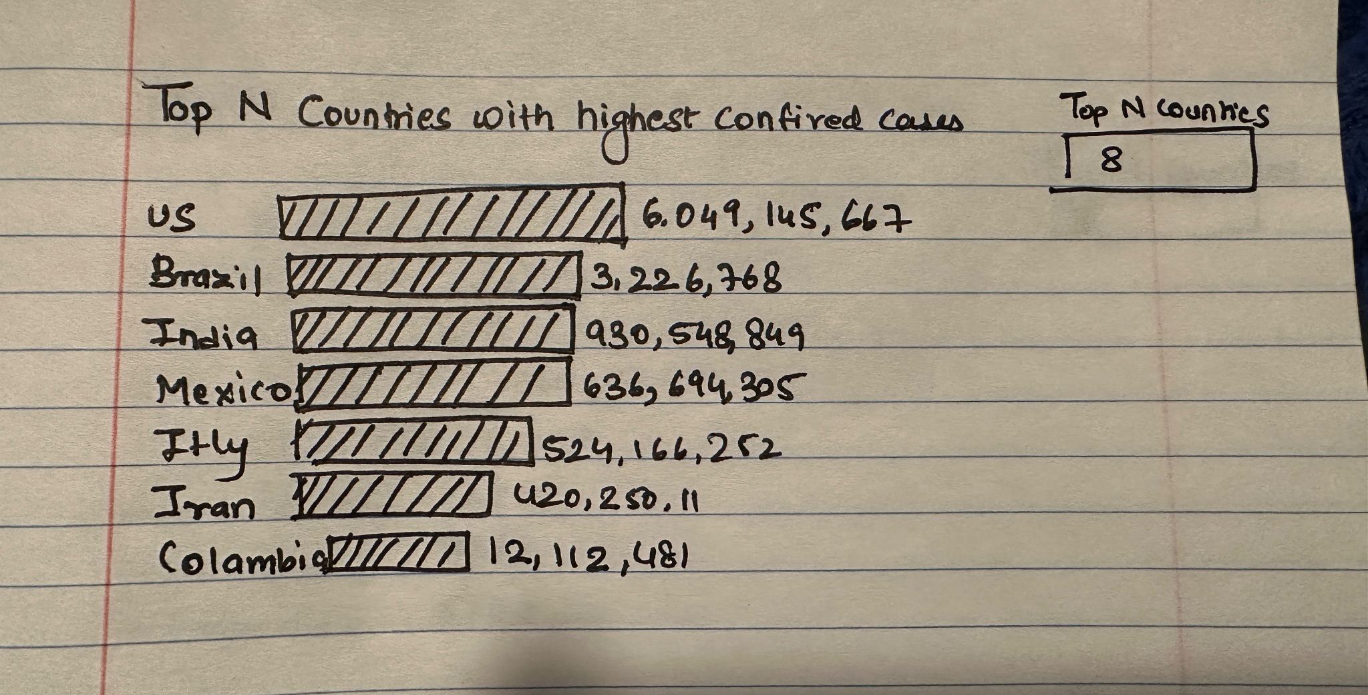

**3.** Top N Countries/states with the highest number of Recoveries: Bar Graph, Top N filter.

**Explanation**: This visualization depict Top N countries with highest number of recoveries. The user can enter the Top N value in the filter and based on the value the graph will Change.

**Chart Type**: Vertical Bar Chart

**Pre-Attentive Attributes:** Color Hue, length

**Rough Sketch**:

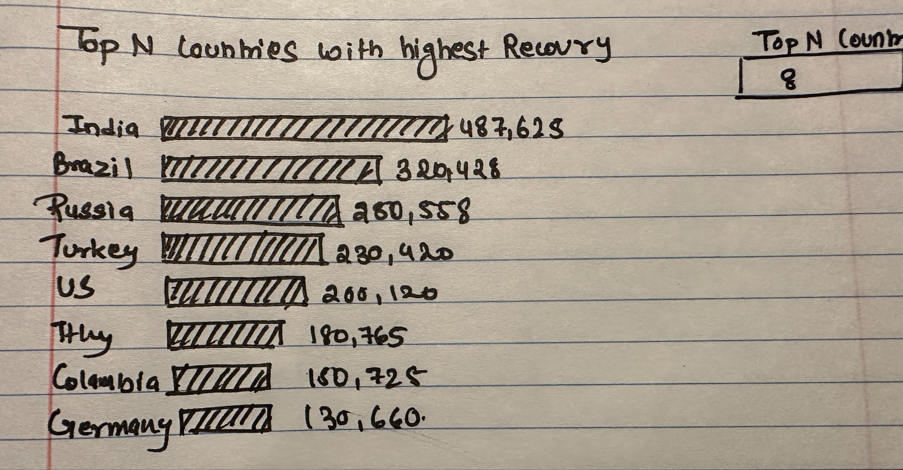

**4.** Daily trends of the total number of covid confirmed cases by countries: **Explanation**: This visualization depict the cumulative number of covid cases confirmed in different country on daily basis. User can filter this plot by month and year.  
**Chart Type**: Bar Chart

**Pre-Attentive Attributes:** Color, length

**Rough Sketch:**

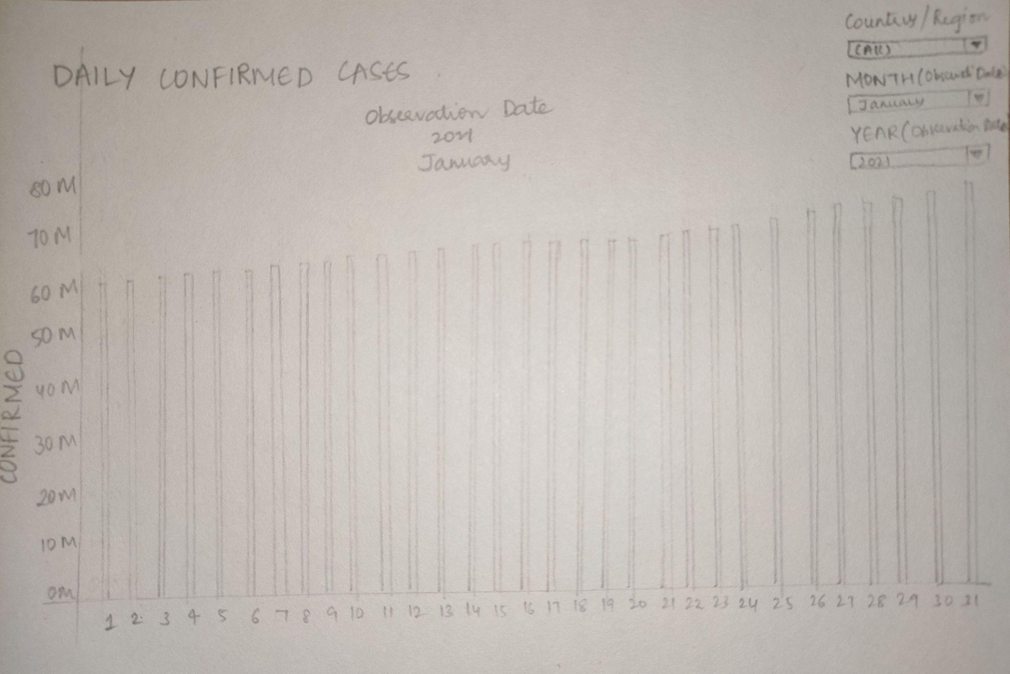

**5**. Daily trends of the total number of covid recoveries by countries:

**Explanation**: This visualization depict the cumulative number of covid cases confirmed in different country on daily basis. User can filter this plot by country, month, and year.  
**Chart Type**: Bar Chart

**Pre-Attentive Attributes:** Color, length  
**Rough Sketch:**

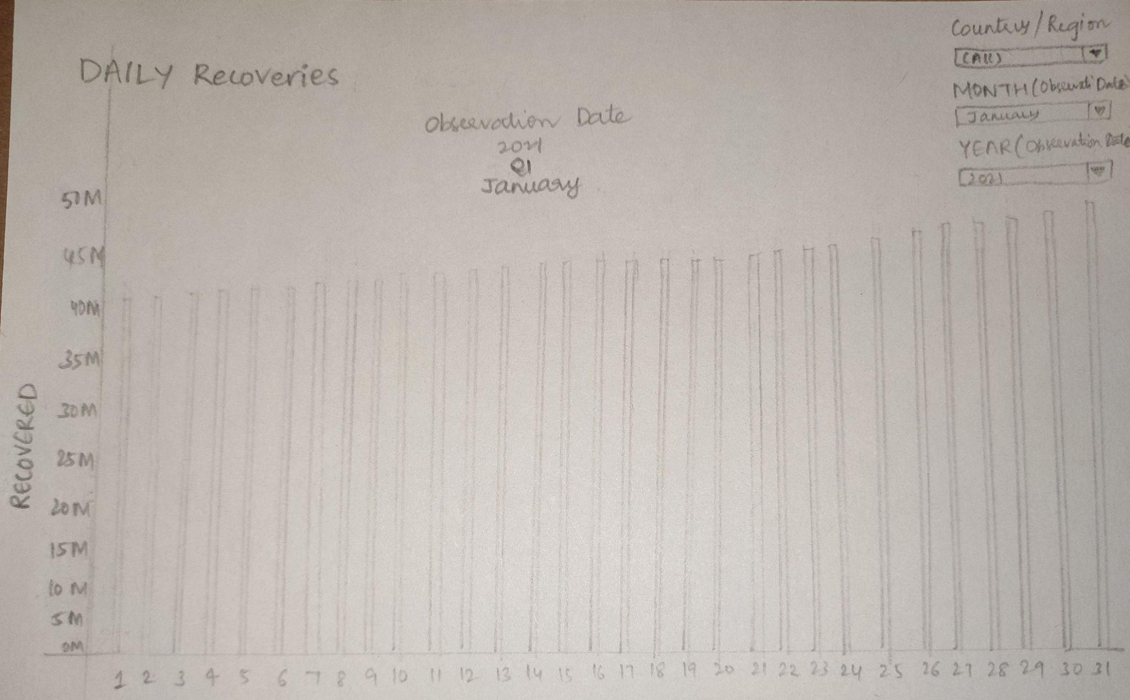

**6**. Daily trends of the total number of covid death by countries:

**Explanation**: This visualization depict the cumulative number of covid cases confirmed in different country on daily basis. User can filter this plot by country, month, and year.  
**Chart Type**: Bar Chart **Pre-Attentive Attributes:** Color, length

**Rough Sketch:**

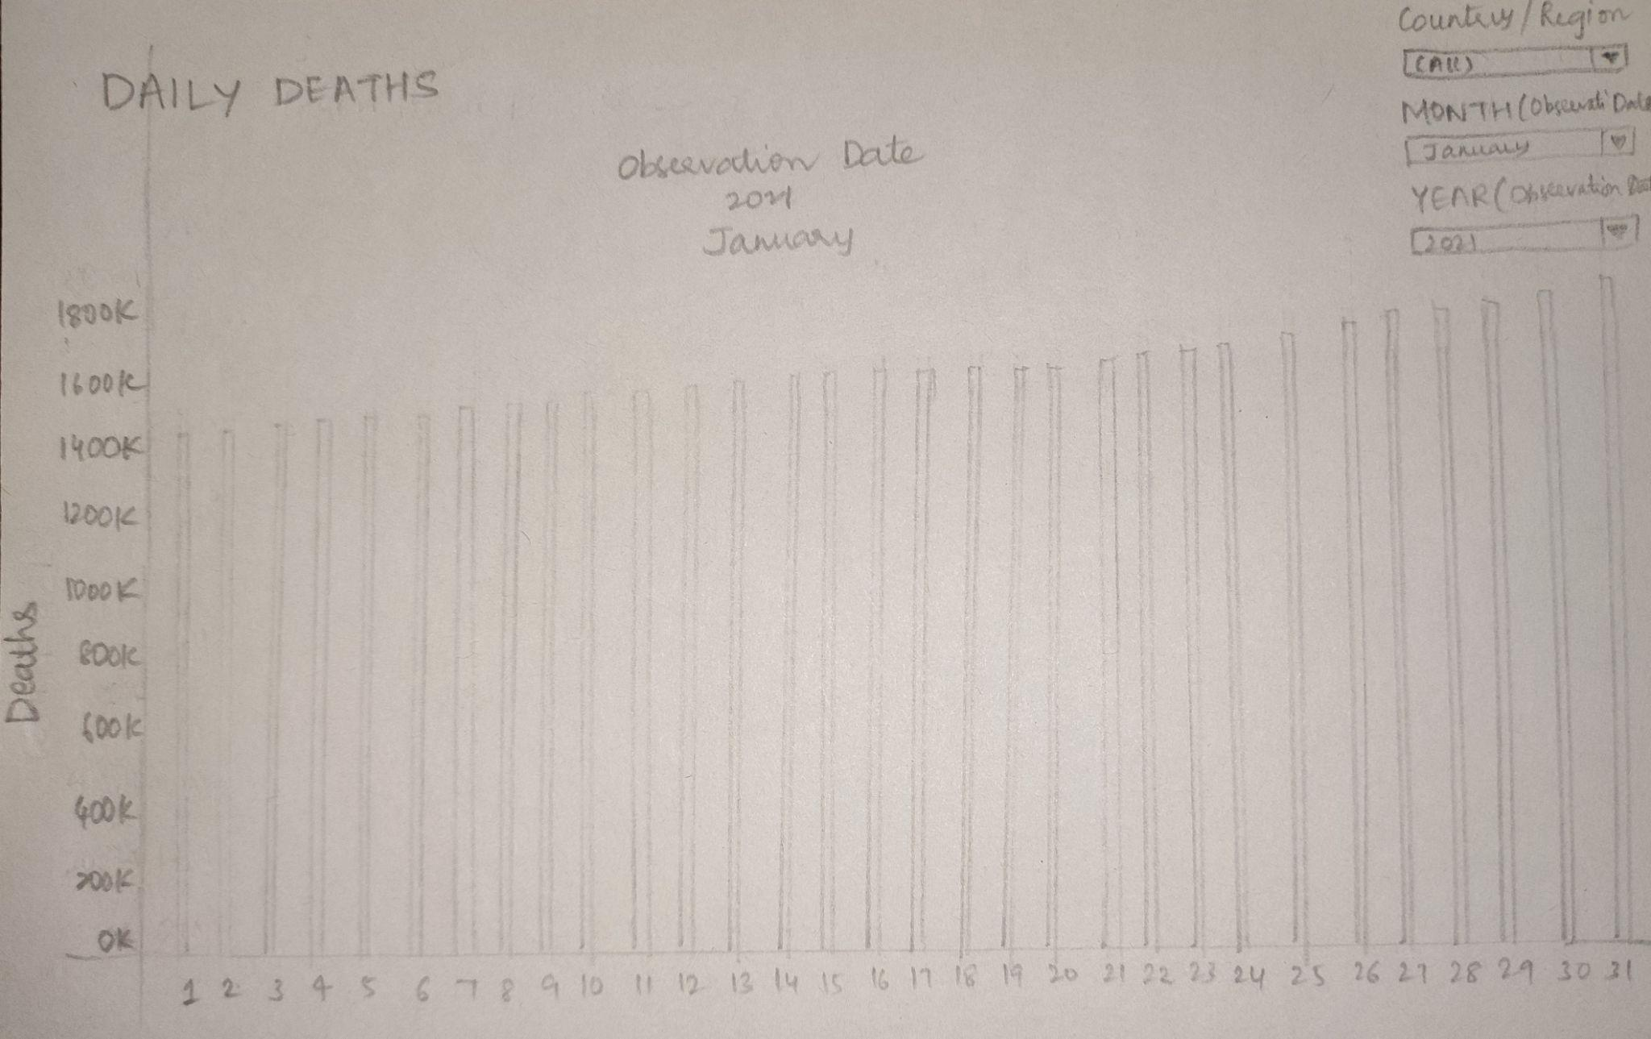

**7.** Quarterly trends of the total number of covid confirmed cases by countries:

**Explanation**: This Visualization will depict the quarterly trends of total confirmed cases by country ​​starting from Quarter 1 2020 till Quarter 2 2021 by using Countries, Year, Quarter filters which creates user interaction. We used orange color for confirmed covid cases.

**Chart Type:** Bar chart

**Pre-Attentive Attributes:** Color, length

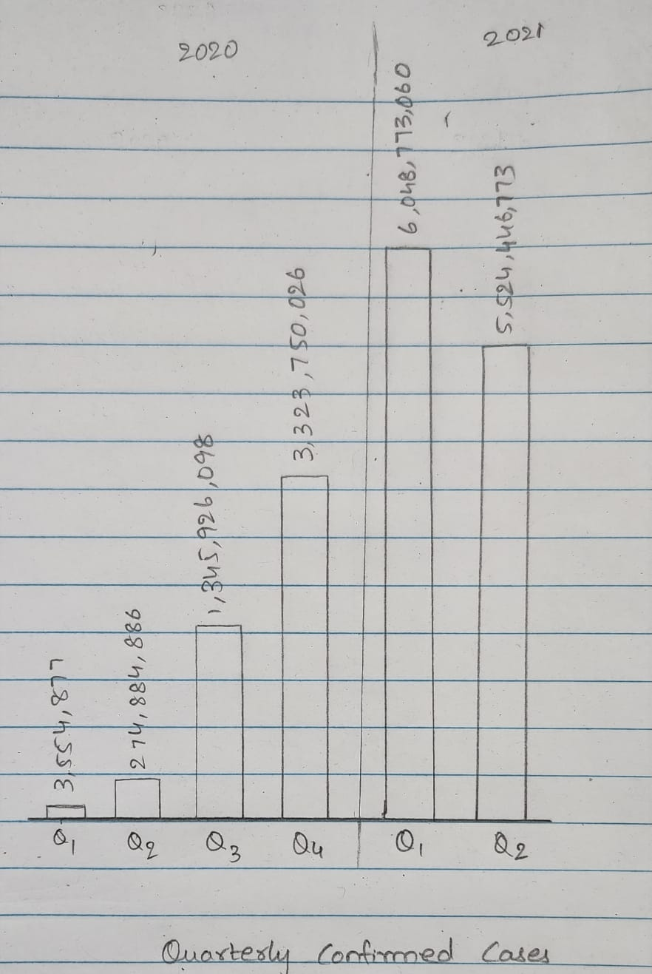

**8.** Quarterly trends of the total number of covid recoveries by countries:

**Explanation**: This Graph is used to showcase the quarterly trends of total recoveries by country ​​starting from Quarter 1 2020 till Quarter 2 2021by using Countries, Year, Quarter filters which creates user interaction. We used green color for recoveries.

**Chart Type:** Bar chart

**Pre-Attentive Attributes:** Color, length

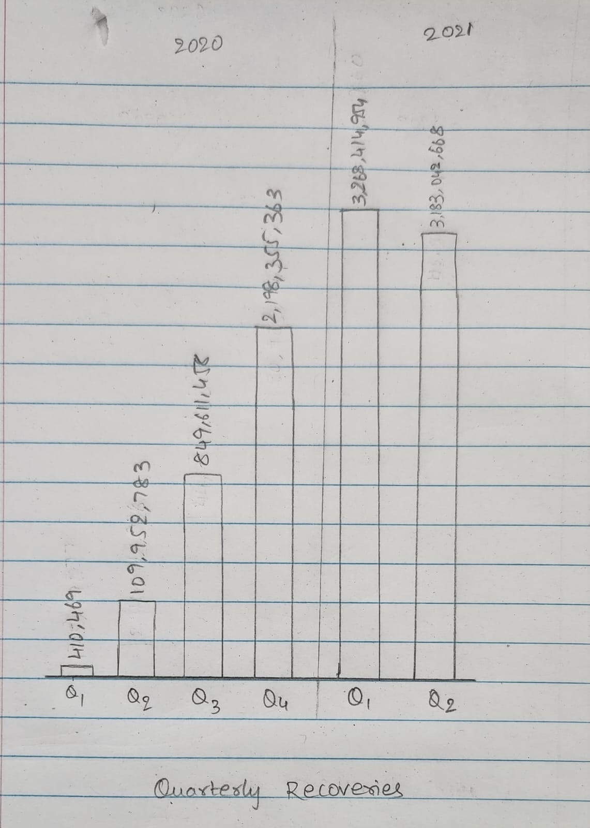

**9.** Quarterly trends of the total number of covid deaths by countries:

**Explanation**: This visualization is used to showcase the quarterly trends of total deaths by country ​​starting from Quarter 1 2020 till Quarter 2 2021. We used Country, Year, Quarter filters which create user interaction and also, alerting color red for deaths.

**Chart Type:** Bar chart

**Pre-Attentive Attributes:** Color, length

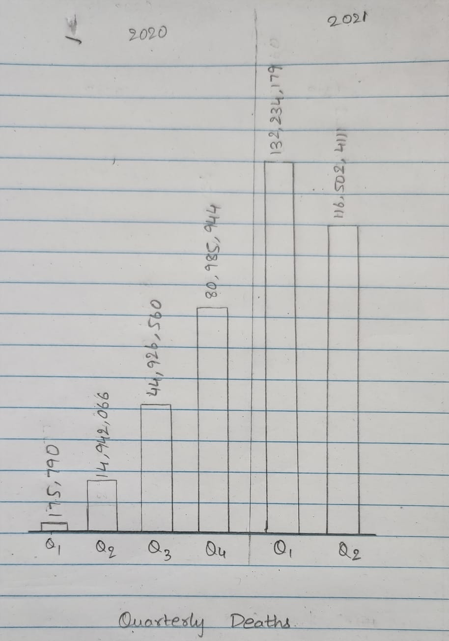

**10.** Monthly trends of the total number of covid positive cases by all countries:

**Explanation**: To maintain the minimum data-ink ratio, we believe line graph is the best fit to visualize the data of the number of Covid-19 confirmed cases month by month starting from January-2020 to May-2021. We’ve used Country, year, and months.

**Chart Type:** Line graph

**Pre-Attentive Attributes:** Color

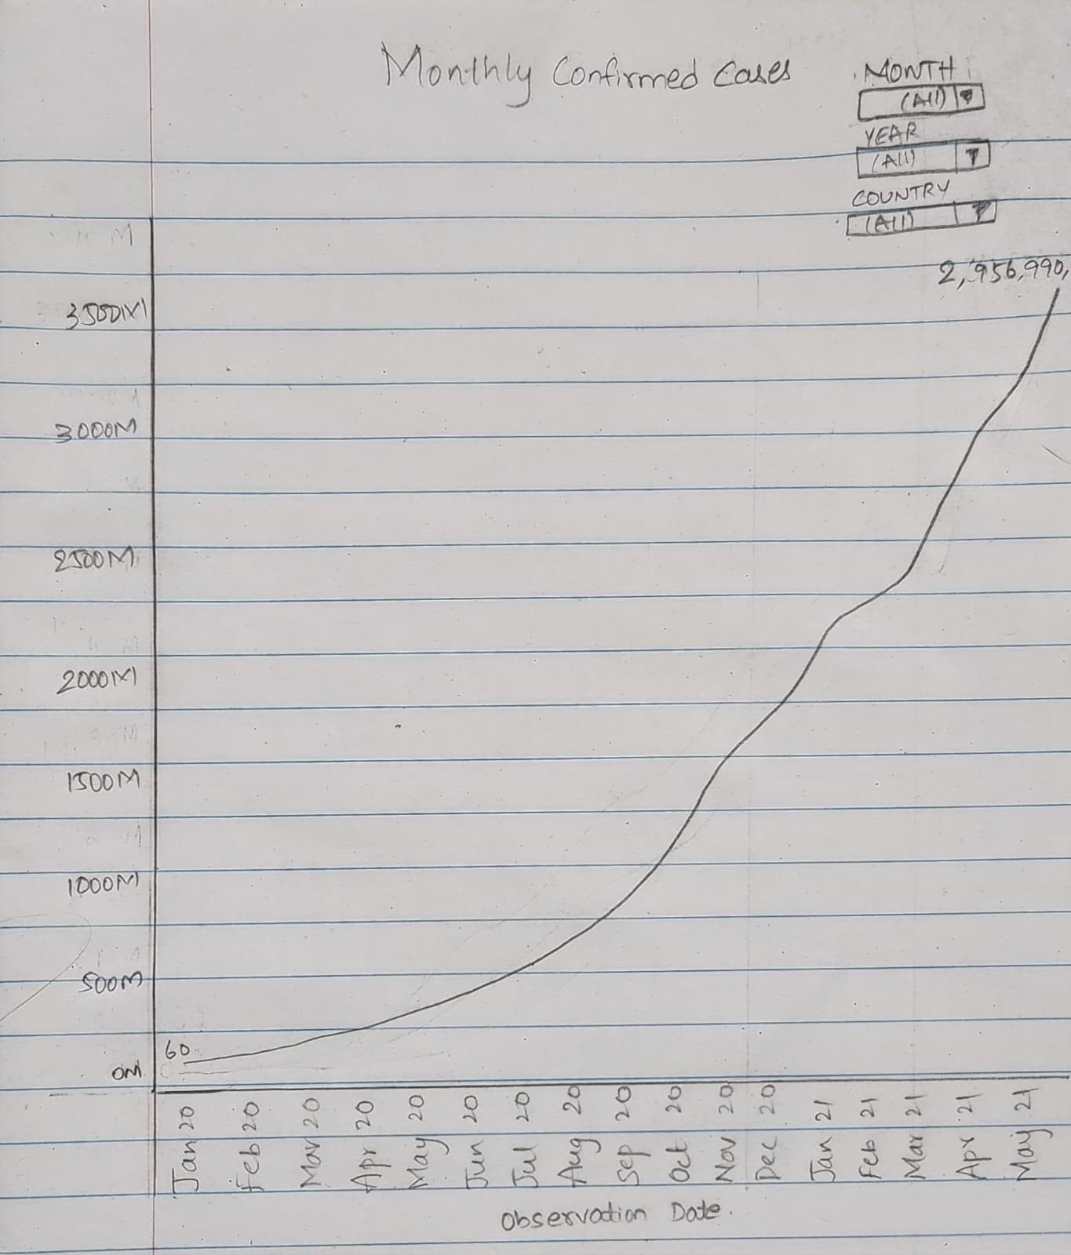

**11.** Monthly trends of the total number of Covid-19 recoveries by all countries: To maintain the minimum data-ink ratio, we believe line graph is the best fit to visualize the data of the number of Covid-19 recovery cases month by month starting from January-2020 to May-2021. We’ve used Country, year, and months.

**Chart Type:** Line graph

**Pre-Attentive Attributes:** Color

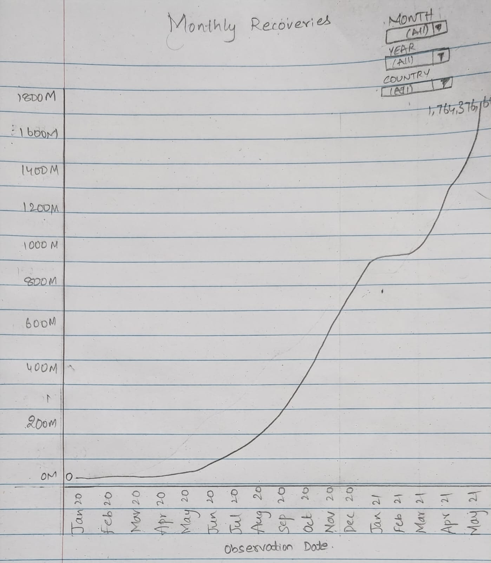

**12.** Monthly trends of the total number of Covid-19 deaths by all countries:

**Explanation:** To maintain the minimum data-ink ratio, we believe line graph is the best fit to visualize the data of the number of Covid-19 death cases month by month starting from January-2020 to May-2021. We’ve used Country, year, and months.

**Chart Type:** Line graph

**Pre-Attentive Attributes:** Color

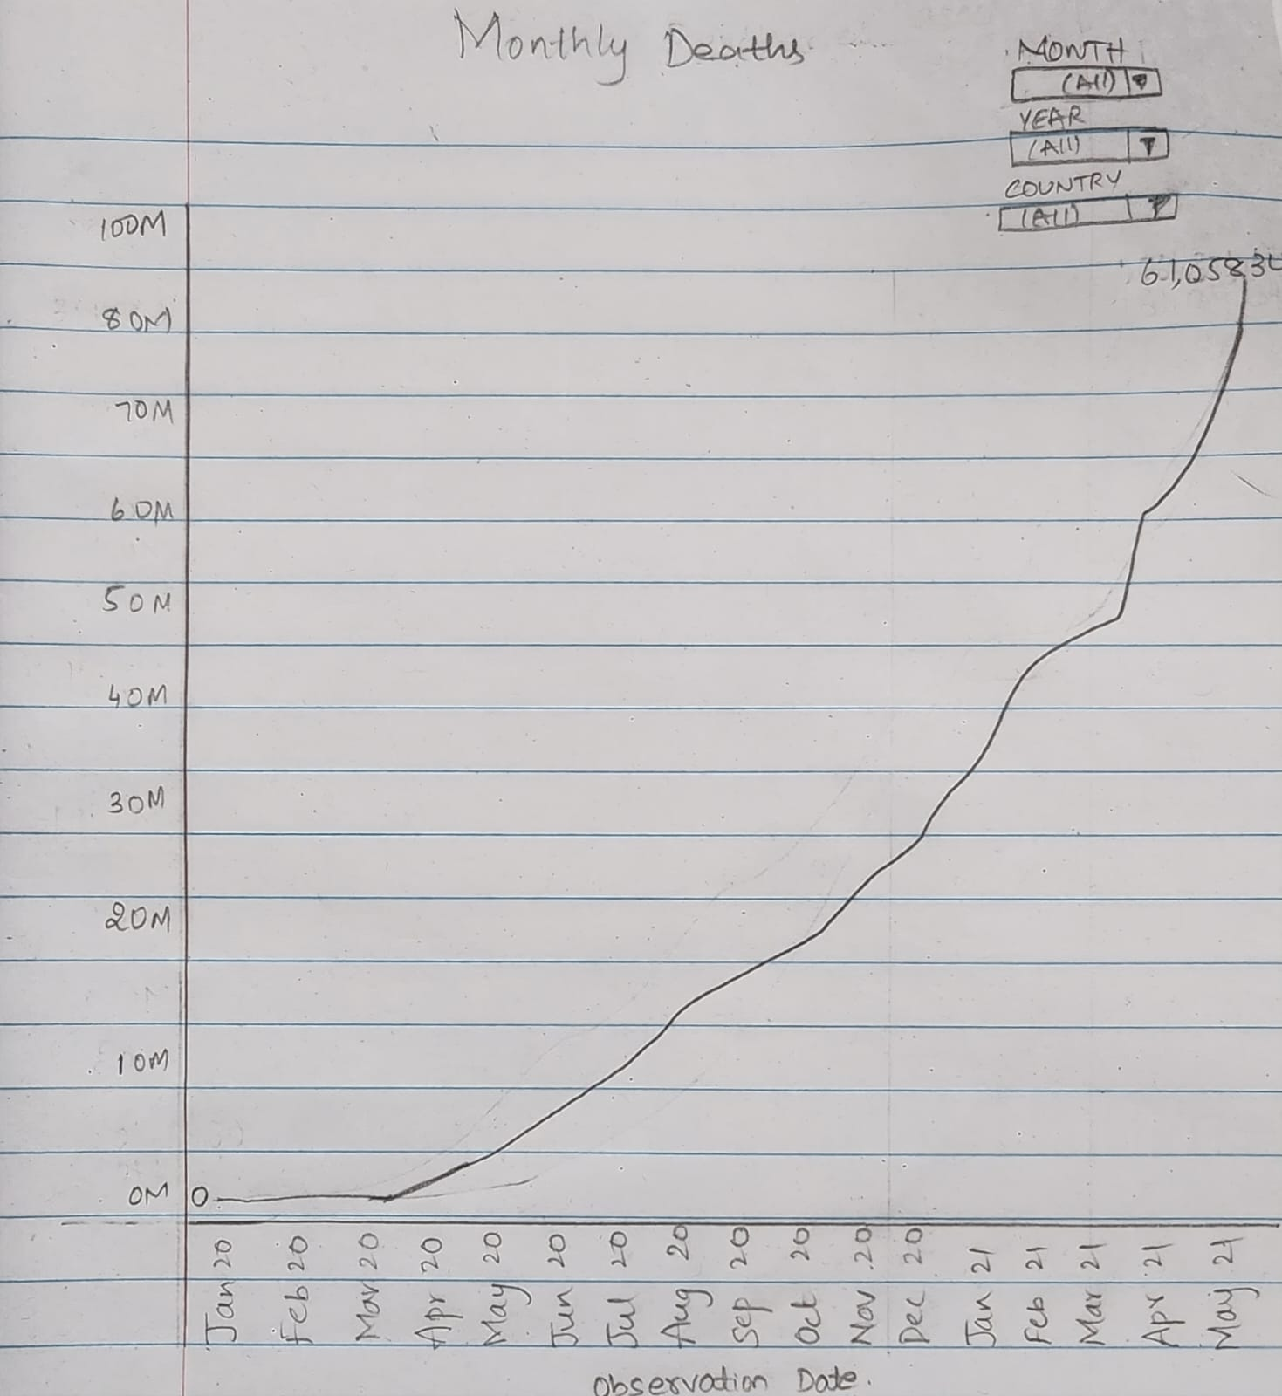

**13.** Trend showing daily cases, recoveries, and death by countries/state.

**Explanation:** This visualization represents the distribution of confirmed, recovered cases and death across the countries. The higher the number the darker the color in mass gets. Users can use the Countries, month, and year filters to interact with the visualization.

**Chart Type:** Choropleth Map

**Pre-attentive attributes**: Hue color, and hue saturation.

**Rough Plot:**

**14.** Trend showing Quarterly cases, recoveries, and death by countries/state.

**Explanation**: This visualization is used to showcase the quarterly trends of all the confirmed cases, deaths and recoveries by country ​​starting from Quarter 1 2020 till Quarter 2 2021. We used Country, Year, Quarter filters which create user interaction and also used colors like Orange for Confirmed, Red for Deaths and Green for Recoveries.

**Chart Type:** Bar Chart

**Pre-Attentive Attributes:** Color, length

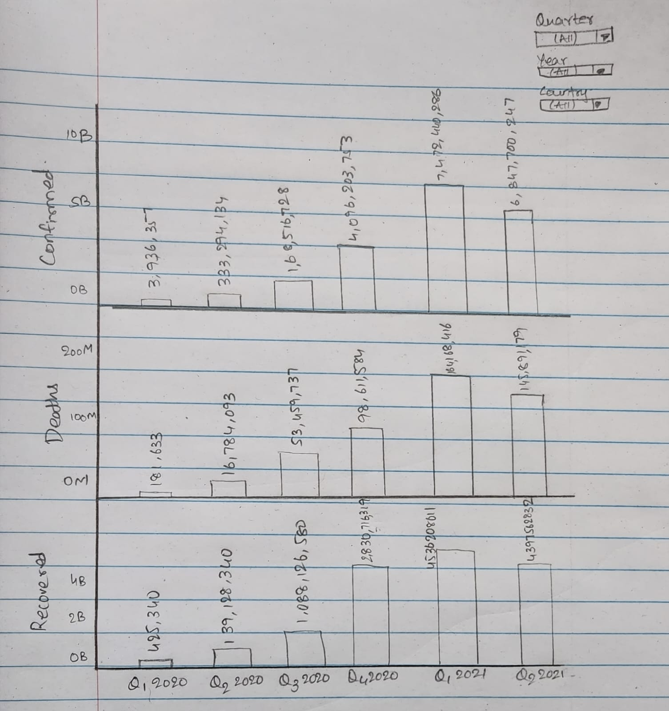

15. Trend showing monthly cases, recoveries, and death by countries:

**Explanation**: This visualization is used to showcase the monthly trends of all the confirmed cases, deaths and recoveries by country ​​starting from January-2020 till May-2021. We used Country, Year, Month filters which enables user interaction. We also used different colors for confirmed cases, for death cases, and for recoveries.

**Chart Type:** Line graph

**Pre-Attentive Attributes:** Color

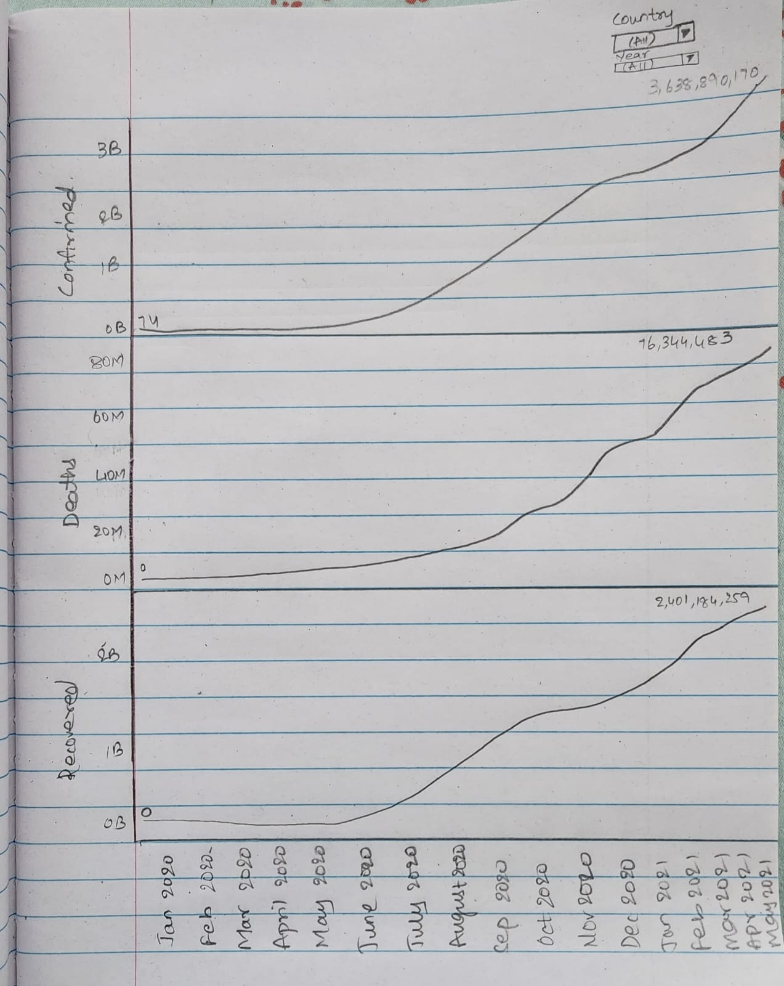

**16.** Total confirmed cases, recovery, and death in different nations across the world:

**Explanation:** This visualization represents the distribution of confirmed, recovered cases and death across the countries. The higher the number the darker the coler in maos get.User can use Countries, month and year filter to interact with the visualization.

**Chart Type:** Choropleth Map

**Pre attentive attributes**: Hue color, and hue saturation.

**Plot:**

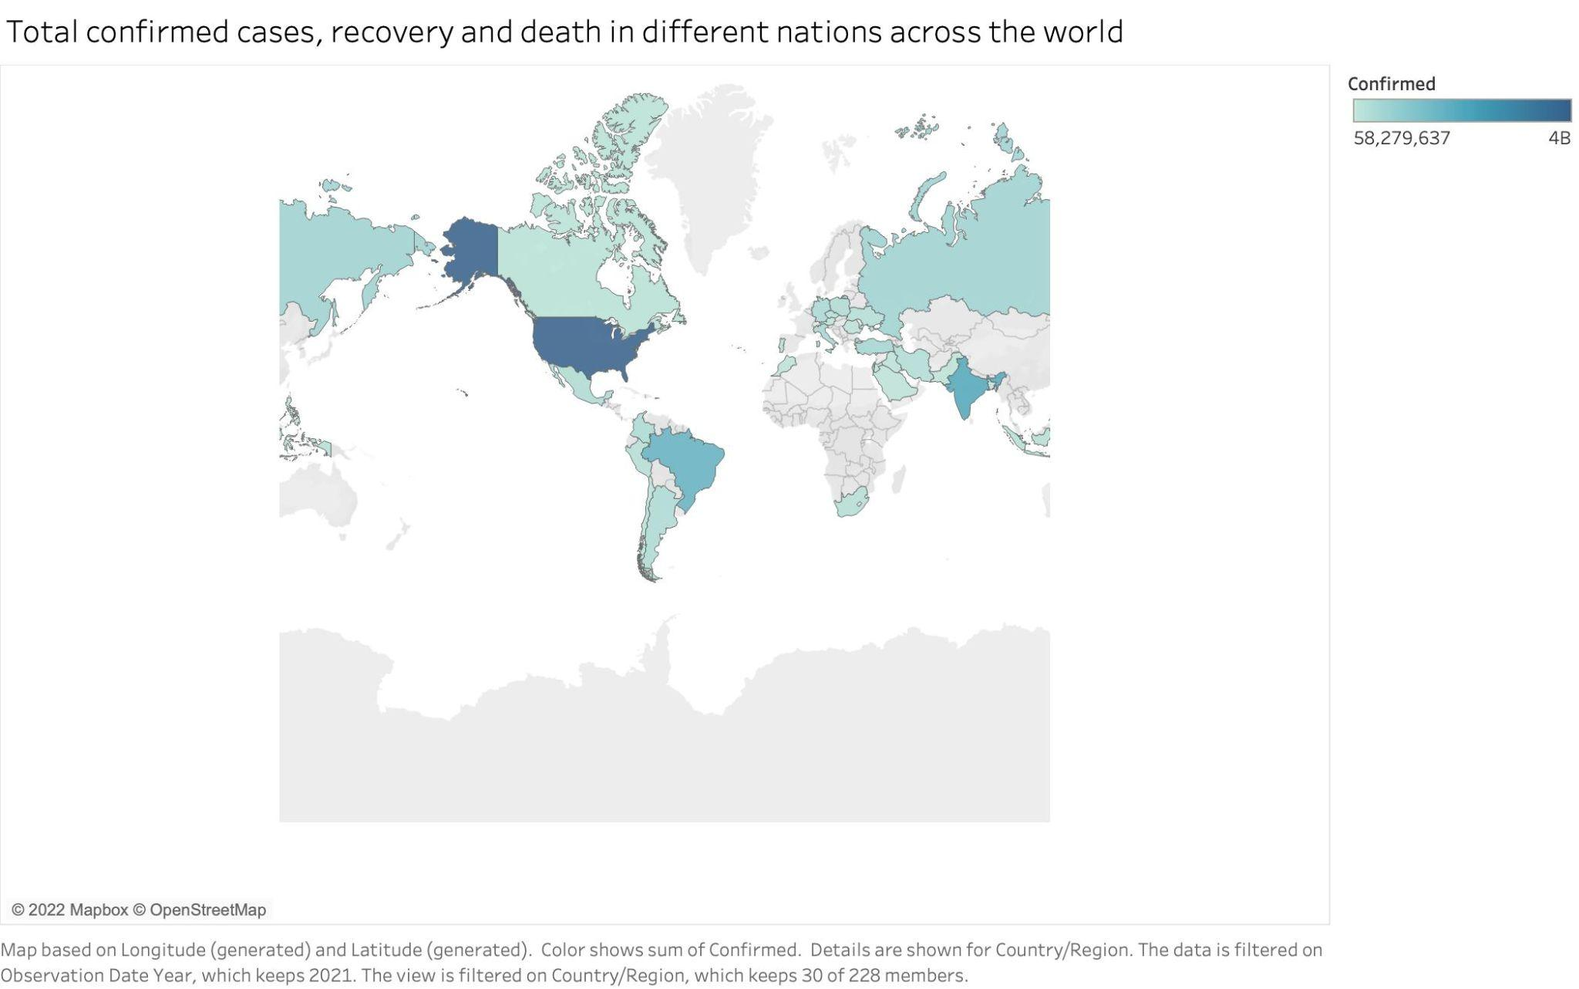

17. Total number of Confirmed, Recoveries and Deaths per year/month/day:

**Explanation**: Here the bar graph shows total number of confirmed cases, deaths, and recoveries using filters for year, month, and date for user interaction. We used colors like Orange for Confirmed, Red for Deaths and Green for Recoveries.

**Chart Type:** Bar Chart

**Pre-Attentive Attributes:** Length, Color

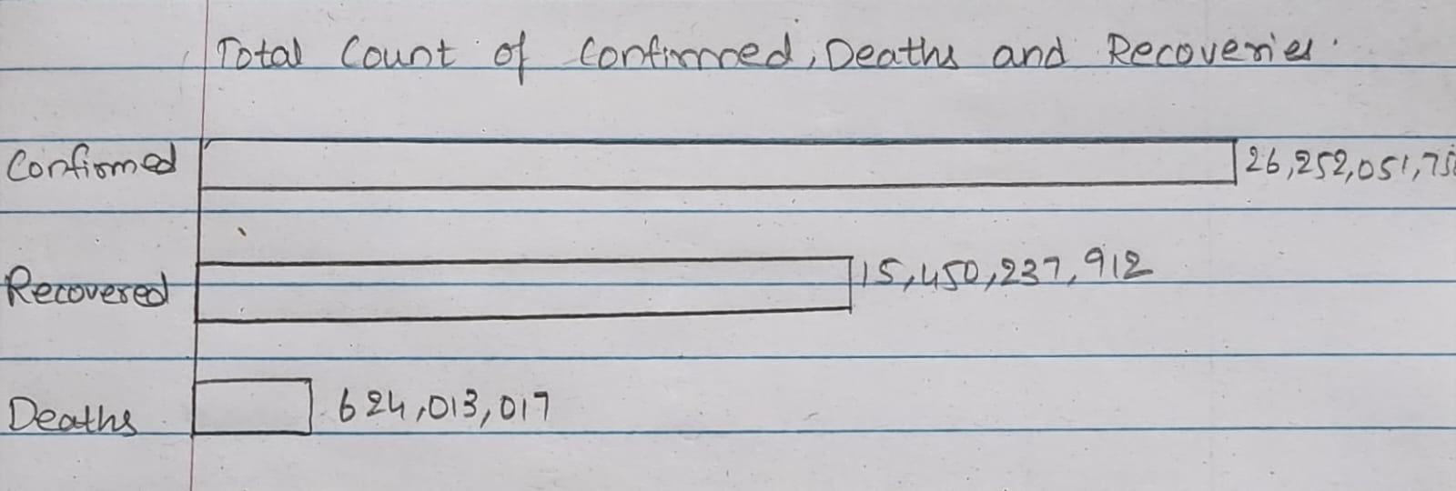

* **Dashboard Interactivity**

In question 1,2,3 we are using Top n filter in which the user will put a inter value and based on the value the chart will change and show the Top N countries with highest number of confirmed, recoveries and death.

In question 4,5,6,7,8,9 we are going to add Month, year and country filter. So the user can see the daily trends by selecting month, year and country from the drop down.

In question 10,11,12 we are putting country filter so the user can see monthly trends by country.

In question 13 the Choropleth map will change based on Month, year and country filter.

In question 14,15,16 and 17 we are putting Month and Year filter.

References

Mural Link

https://app.mural.co/t/team55769/m/team55769/1668114250029/2153fa6b771d48cf7e7c5c0be7709a9c7eadabef?sender=ucaba08cce9c57a8852bd7940

**Dataset**

<https://www.kaggle.com/datasets/sudalairajkumar/novel-corona-virus-2019-dataset>